**Impact of Short- and Long-Term Exposure to Elevated Seawater pCO2 on Metabolic Rate and Hypoxia Tolerance in *Muusoctopus sp*.**

Ariana Coast, Eden Kim, Stephanie Reynoso, Tanner Buller

**Introduction**

The level of ocean acidification has been rising steadily due to increased CO2 emissions, where “one-third of all anthropogenic CO2 is absorbed into the ocean” (Doney et al. 2009). This has significant consequences for calcifying organisms such as crustaceans, but also places stress on organisms through demands of osmoregulation. In many cases, this stress can impair the hypoxia tolerance of the organism and make them susceptible to hypercapnia (harmful buildup of CO2 in the blood-stream) (Rosa et al. 2013).

The octopus genus *Muusoctopus* is largely unstudied due to their normally deep sea range (250-1400 m). Recently however, these octopuses have been found in Burrows Bay located in Salish Sea, an abnormally acidic environment. This study is the first to investigate the long and short term effects of hypercapnia on *Muusoctopus sp*. We hypothesized that extreme amounts of CO2 would lead to a suppression of aerobic metabolism and elevated critical oxygen pressure (Pcrit).

**Research Questions**

* **How do *Muus* octopuses respond to end-of-century predicted CO2 levels?**
* **How do these octopuses exhibit mass-specific metabolic scaling?**
* **How does acclimatization, if present, affect their critical oxygen pressure?**

**Methods**

Octopus collection

* + 12 *Muusoctopus sp.* were collected in 2021 from Burrows Bay.

Experimental Hypercapnia Treatments

* + 1 and 7 day treatments
  + High/low pCO2  (1000/1800 $μ$ atm)

Analysis of pH and Alkalinity of Treatment Tanks

* + The pH of each treatment tank was determined through a spectrophotometric measurement of pH in seawater
  + Total alkalinity in seawater using open-cell titration

Measurement of Routine Metabolic Rate (RMR)

* + PyroScience Firesting O2 flow-through cells (OXFTC2)

Measurement of Pcrit

* + Closed-system respirometry

Statistical Analysis

* + RMR: Two-way ANOVA, Tukey post-hoc
  + Graphical representation of RMR vs. Mass for each treatment and duration
  + Pcrit: Two-way ANOVA, Tukey post-hoc

**Results**

Results from statistical analysis (Two-way ANOVA, Tukey post-hoc) are as follows:

* RMR
  + **7-day 1000 vs. 1-day 1000 p-value: 0.0194**
  + **1-day 1800 vs. 1-day 1000 p-value: 0.0426**
  + 7-day 1800 vs. 1 day 1000 p-value: 0.4671
  + 1-day 1800 vs. 7-day 1000 p-value: 0.8553
  + 7-day 1800 vs. 7-day 1000 p-value: 0.1354
  + 7-day 1800 vs. 1-day 1800 p-value: 0.3284
* Pcrit
  + No statistical difference between pCO2, treatment length, and Pcrit (p-value > 0.05).
* RMR vs. Mass (No statistical test done)
  + 1-day 1800 (r2 = 0.2323) Average RMR: 2.111
  + 1-day 1000 (r2 = 0.2874) Average RMR: 2.598
  + 7-day 1800 (r2 = 0.0701) Average RMR: 2.354
  + 7-day 1000 (r2 = 0.1434) Average RMR: 1.977 $μ mol/g/hr$

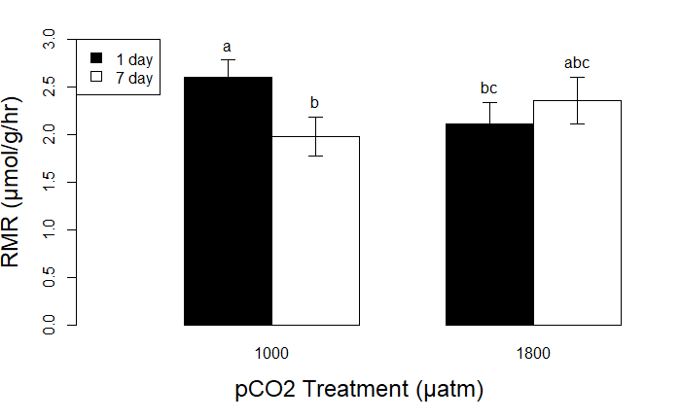

Graph 1. A barplot of the RMR for all 12 samples in 1-day and 7-day treatments

at 1000 and 1800 pCO2. A two-way ANOVA and Tukey post-hoc determined that

there was a significant difference between the 1-day 1000 and 1-day 1800 pCO2

treatment (p-value = 0.043), and a difference between the 1-day 1000 and 7-day

1000 pCO2 treatment (p-value = 0.019). The letters above the bars denote the results

from the Tukey post-hoc.

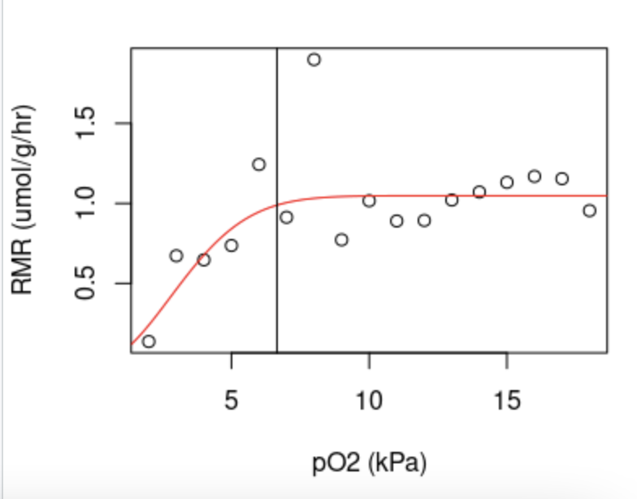

Graph 2. A graph between RMR ($μ$ mol/g/hr) and

pO2 (kPa) for all 12 *Muusoctopus sp.* to determine

the Pcrit. The Pcrit is shown in the blue, vertical line*.*

This is a sample graph of the 1800 pCO2, 7-day

treatment on July 07, 2021.

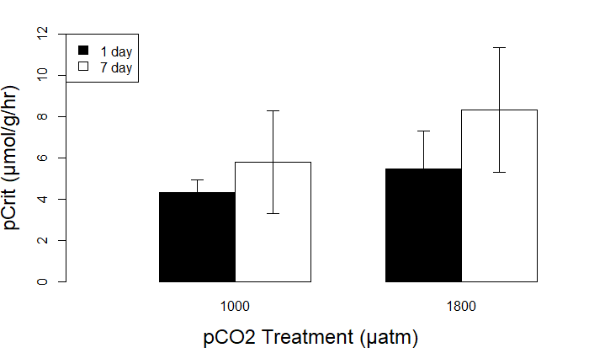

Graph 3. A barplot of the Pcrit for the 1-day and 7-day treatments at 1000 and

1800 $μ$ atm. A two-way ANOVA determined that there was no significance

between the Pcrit , the duration, and pCO2 concentration (p>0.05).

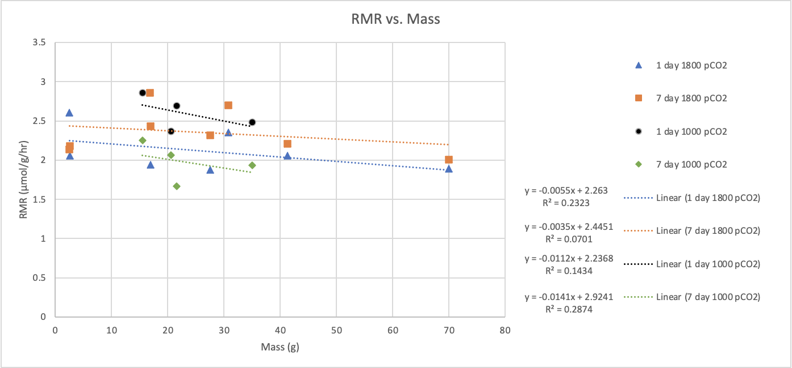

Graph 4. The graphical relationship between RMR ($μ$ mol/g/hr) and mass (g) for all 12 *Muusoctopus sp.* Color coded based on treatment and duration of treatment. 1-day 1800 pCO2 (blue), 7-day 1800 pCO2 (orange), 1-day 1000 pCO2 (grey), and 7-day 1000 pCO2 (yellow). Each set of data is shown with a linear trendline, where the equation and R2 values are listed.

| Tank | Average pCO2 (µatm) | Standard Deviation |
| --- | --- | --- |
| 1 | 1091 | ± 231 |
| 2 | 1133 | ± 243 |
| 3 | 987 | ± 139 |
| 4 | 1049 | ± 123 |
| 8 | 1747 | ± 221 |
| 9 | 2021 | ± 308 |
| 10 | 1839 | ± 442 |
| 11 | 1780 | ± 242 |

Table 1. The average pCO2 and standard deviation

of pCO2 for each treatment tank.

| Parameter | High CO2 | Low CO2 |
| --- | --- | --- |
| pH | 7.415 | 7.624 |
| Total alkalinity (µmol/kg) | 0.002053 | 0.002037 |
| PCO2 (µatm) | 1804 | 1063 |

Table 2. The average pH, total alkalinity, and

pCO2 for all the tanks with high pCO2 (1800

µatm) and the tanks with low pCO2 (1000 µatm).

**Conclusions**

**RMR**

* Based on the statistical analysis Tukey post-hoc, only two values were significant with a p-value < 0.05:
  + 7-day 1000 vs. 1-day 1000 p-value = 0.019
  + 1-day 1800 vs. 1-day 1000 p-value = 0.043
* The octopus in 1-day treatments of 1000 pCO2 saw an increase in RMR in comparison to the 7-day treatment. Thus, the *Muusoctopus sp.* may be able to acclimate to their environment over longer periods of time.
* Our data shows that the RMR of *Muusoctopus sp.* was affected by elevated pCO2 (1800atm) when the octopus had only been in 1 day of treatment.

**Pcrit**

* The Pcrit was not affected by CO2 concentration or treatment length (p-value > 0.05).

**RMR vs. Mass**

* The 1-day 1800 treatment and 1-day 1000 treatment seemed to have the greatest correlation (r2 ) in relation to mass. The greater the mass, the lower the RMR.



**Literature Cited**

* Doney S.C., V. J. Fabry, R.A. Freely, and J.A. Kleypas. 2009. Ocean acidification: the other CO2 problem. Anny Rev Mar Sci 1:169.192.
* Onthank K.L., L.A. Trueblood, T. Schrock-Duff, L.G. Kore. 2020. Impact of Short- and Long-Term Exposure to Elevated Seawater PCO2 on Metabolic Rate and Hypoxia Tolerance in Octopus rubescens. Physiological and Biochemical Zoology, 94(1), 1-11.
* Rosa R., K. Trubenbach, T. Repolho, M. Pimentel, F. Faleiro, J. Boavida-Portugal, M. Baptista, et al. 2013. Lower hypoxia thresholds of cuttlefish early life stages living in a warm acidified ocean. Proc R Soc B 280:20131695

**Acknowledgements**

We would like to thank two individuals for making this study possible: Dr. Trueblood for his guidance throughout the **ENTIRE** process and Dr. Onthank for creating a simplified RStudio script for us to be able to compute RMR and Pcrit. We would also like to thank Rosario Beach Marine Laboratory for letting us use their facilities.

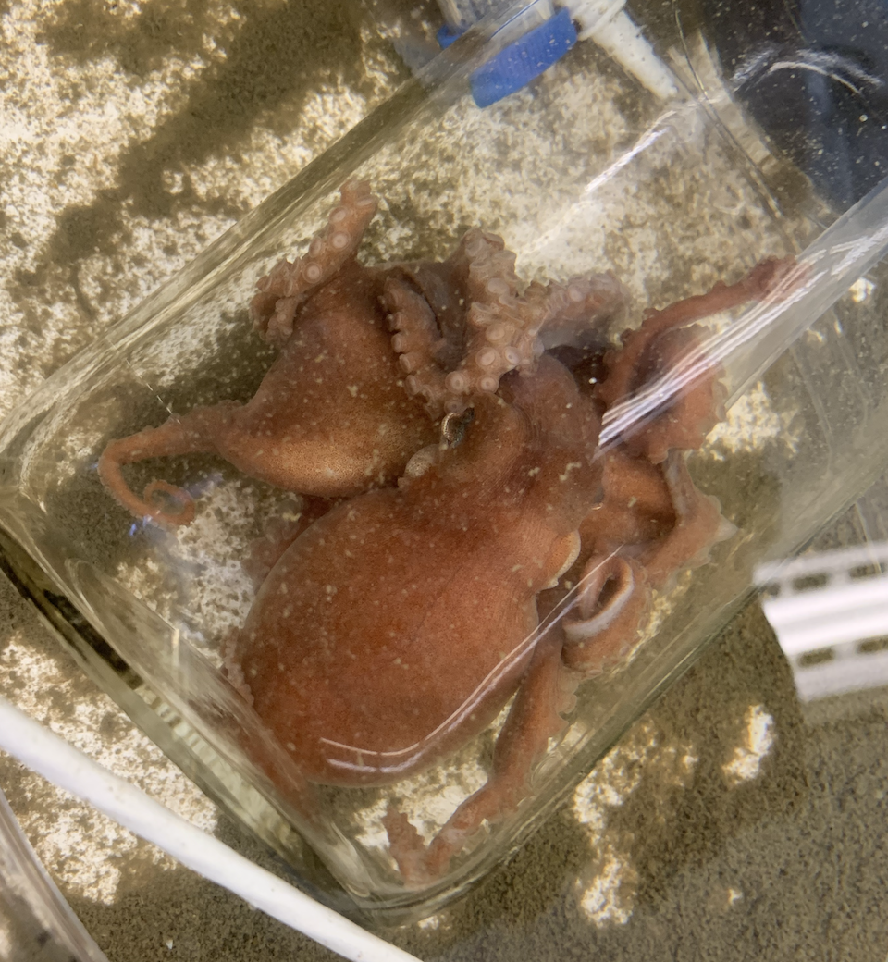

Figure 1. Octopus No.1 on 1800 RMR 1-day

treatment, with a mass of 16.8 grams.

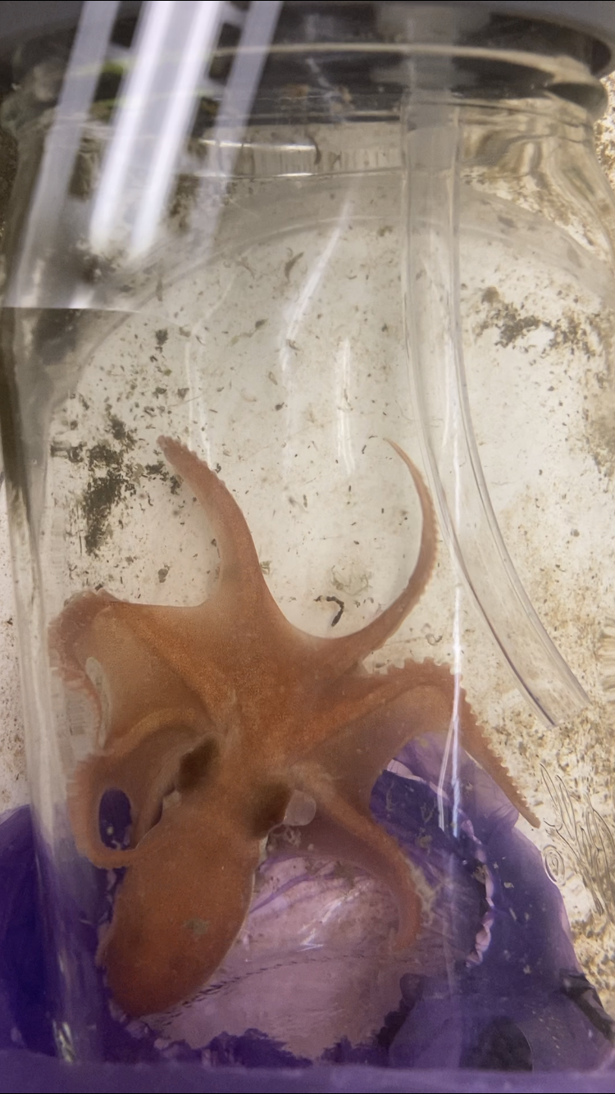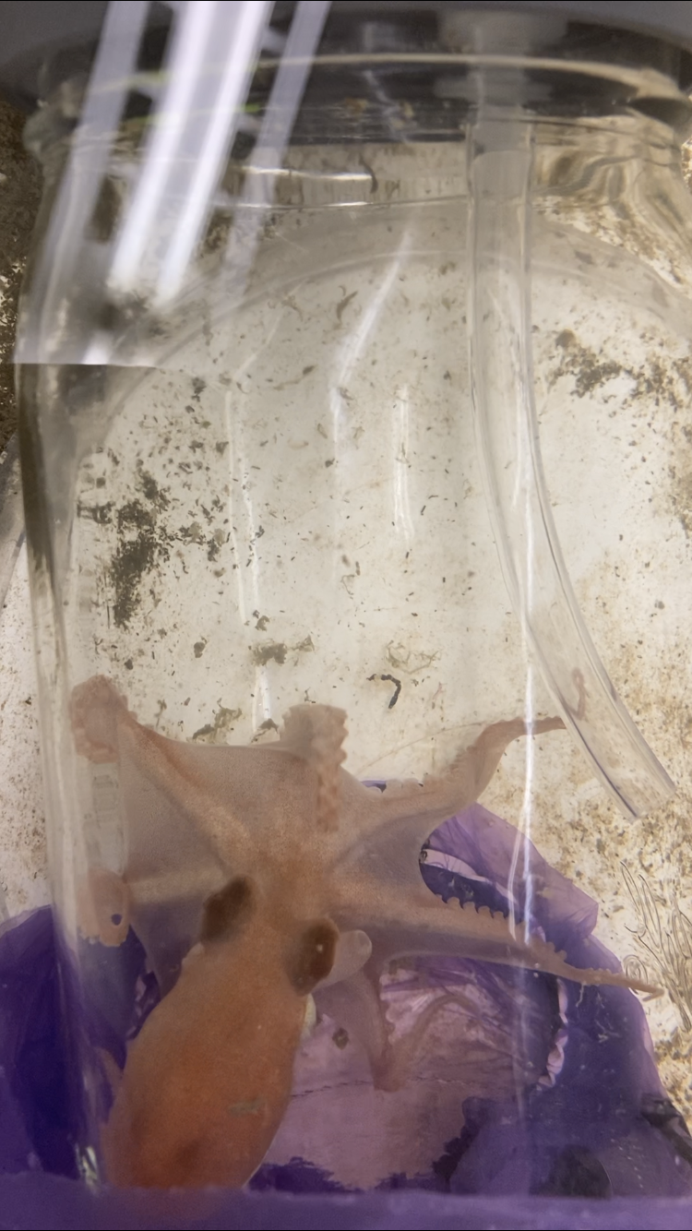

Figure 2. Octopus No.2 on 1000 RMR 7-day treatment, with a mass of 35.0 grams.

Left side shows the octopus at the beginning of treatment with normal coloration.

Right side shows the octopus at the end of treatment with less coloration.

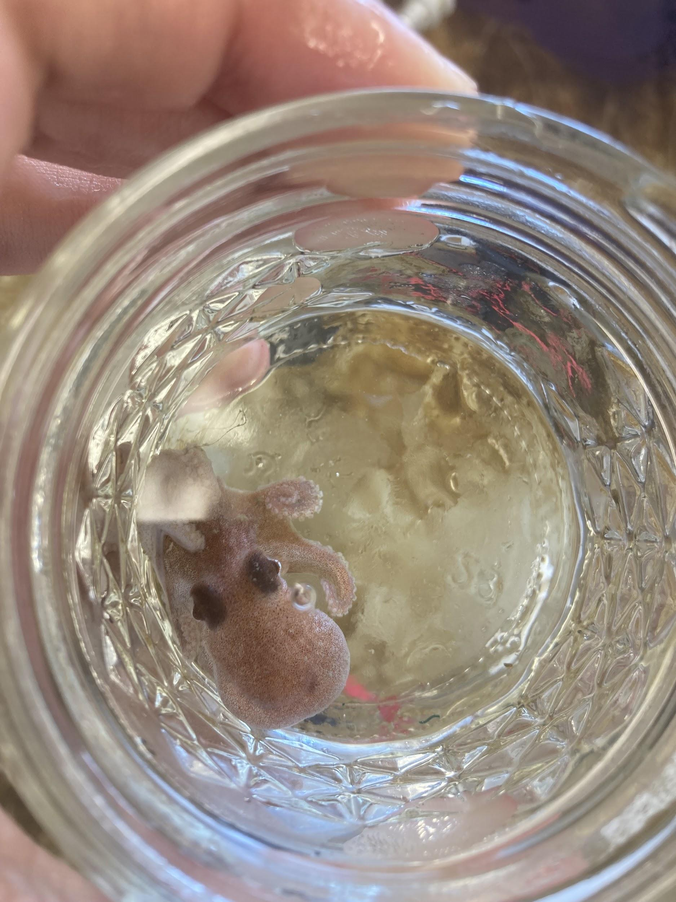

Figure 3. Octopus No.3 on 1800 RMR 7-day

treatment, with a mass of 2.6 grams.

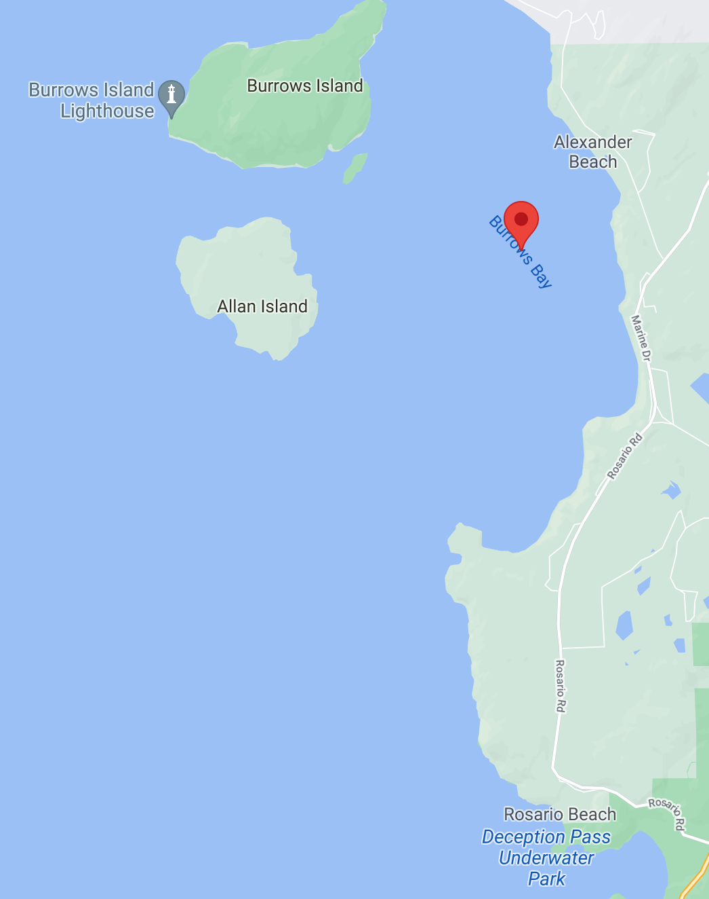

Figure 4. A map of the octopus collection site, Burrows Bay, Washington, USA

